

**KINZA MAJEED**

**F2023065380**

**MODELING REQUIREMENTS ENGINEERING FOR BANK MANAGEMENT SYSTEM**

Bankify

*Bank in your pocket.*

**Revision History**

|  |  |  |  |
| --- | --- | --- | --- |
| **Date** | **Version** | **Description** | **Author** |
| 15/Dec/2024 | 1.0 | Scope | Kinza |
| 17/Dec/2024 | 1.1 | Functional/Non-Functional Requirements | Kinza |
| 20/Dec/2024 | 1.2 | Use Case Description | Kinza |
| 22/Dec/2024 | 1.3 | Use Case Diagram | Kinza |
| 25/Dec/2024 | 1.4 | Prototyping | Kinza |
| 1/Jan/2025 | 1.5 | DFD Description | Kinza |
| 2/Jan/2025 | 1.6 | DFD Level 0/1 | Kinza |
| 9/Jan/2025 | 1.8 | DFD Level 2 | Kinza |
| 10/Jan/2025 | 1.9 | Sequence/Activity  /ARD/EFD/UMLDiagram | Kinza |
| 11/Jan/2025 | 2 | Remaining Documentation | Kinza |

**Contents**

**1.** **Introduction:** 6

**1.1.** **Purpose:** 6

**1.1** **Scope:** 7

**2.** **Overview:** 8

**3.** **System Description:** 8

**4.** **Functional Requirements:** 9

**5.** **Non-Functional Requirements:** 9

**6.** **Actors:** 10

**6.1. Admin:** 10

• **User Management:** 10

• **System Configuration:** 11

• **Security:** 11

• **System Maintenance:** 11

• **Troubleshooting:** 11

• **Monitoring:** 11

• **Compliance:** 11

• **Documentation:** 12

**6.2. User:** 12

• **Individual Customers:** 12

• **Business Customers:** 12

• **Investors:** 12

• **Online Banking Users:** 13

• **Safe Deposit Box Renters:** 13

• **Foreign Exchange Users:** 13

• **Cardholders (Non-Bank Issued):** 13

**7. Use Cases:** 13

**7.1. UC01: Creating Account:** 13

**7.1.1. UC01-1: Create a new account:** 13

**7.2. UC02: Edit Account Details:** 13

**7.2.1. UC02-1: Editing account details of a previously existing account:** 13

**7.3. UC03: Close Account:** 13

**7.3.1. UC03-1: Deleting an already existing account:** 14

**7.4. UC04: Online Shopping:** 14

**7.4.1. UC04-1: Use the account for online shopping:** 14

**7.5. UC05: Transfer Money:** 14

**7.5.1. UC05-1: Making transaction through account:** 14

**7.6. UC06: Withdraw Money:** 14

**7.6.1. UC06-1: Withdrawing money from the ATM:** 14

**7.7. UC07: View transaction history:** 14

**7.7.1. UC07-1: Viewing the transaction history of the account:** 14

**7.8. UC08: Send foreign remittance:** 15

**7.8.1. UC08-1: Making foreign transactions:** 15

**7.9.1. UC09-1: Displaying the account information:** 15

**7.10. UC10: Search account:** 15

**7.10.1. UC10-1: For searching accounts:** 15

**8.** **Dataflow Diagrams:** 16

**8.1.** **Level Zero Diagram of the System:** 17

**8.2.** **Level One Diagram of the System:** 17

**8.3.** **Level Two Diagrams of the System:** 18

**8.3.1.** **Opening an Account:** 18

**8.3.2.** **Online Transaction:** 18

**8.3.3.** **Closing an Account** 19

**8.3.4.** **View Account Details:** 19

**8.3.5.** **Debit/Credit Card Transactions:** 20

**8.3.6.** **Foreign Transactions:** 20

**8.3.7.** **Login to Web/Mobile Application:** 21

**8.3.8.** **Pay Utility Bills:** 21

**8.3.9. Viewing Transaction History:** 22

**9.** **Sequence Diagram of the System:** 24

**10.** **Activity Diagram of the System:** 25

**11.** **UML Diagram of the System:** 26

**12. Graphic User Interface** 27

**12.1 Splash Screen** 27

**12.2 Login Page** 28

**12.3 Home Screen** 29

**12.4 Transaction Page** 30

**12.5 Transaction History Page** 31

**12.6 Profile Page** 32

**12.7 Services Page** 33

**12.8 Utility Bills Page** 34

**12.9 Loan Page** 35

**12.10 Card Application Page** 36

**12.11 Phone Verification Page** 37

**12.12 OTP Verification Page** 38

**13. Code for Back-End of Application** 39

**13.1 Description for Classes** 39

**13.1.1 Customer** 39

**13.1.2 Customer Account (Inherited from Customer)** 40

**13.1.3 Bank (Composition with Customer Account)** 42

# **Introduction:**

This document completely specifies the committed software requirements for Bank Management System, an online registration system available in ABC company. The aim of this project is to study and analyze this current system running in most banks. On the basis of the analysis performed our goal is to develop a requirements specification document that supports all the functional and non-functional requirements with improvements suggested for the current deficiencies.

## **Purpose:**

The purpose of the software requirements specification document is to specify all requirements for the current banking management systems as well as those requirements that are suggested as improvements for the current system. The document explains the information that will be supplied as input to the system, its transformations and the required outputs. It also addresses the interactions between the desired system and its users. This document will also act as an aide for the upcoming object oriented analysis and design of the system. This will help the software designers in developing this system in accordance with the requirements given in this specification. This specification describes all functional and non-functional requirements, constraints, and other factors necessary to provide a complete and comprehensive description of the requirements necessary to design and develop the corresponding software systems

The software developers will use the document for the necessary understanding of the system when implementing and designing. The other concerned person is the client who would be able to understand the attributes and functions of the system being developed.

## **Scope:**

The scope of this document is to completely and correctly specify software requirements for the current bank management system and other requirements that have come up as improvements suggested to be incorporated in the existing system. The following areas are comprehensively covered in the document

* System Process Flow
* Functional Requirements
* Non-Functional Requirements
* List of Actors using the system
* Use-Cases
* System Architecture Diagram
* Data Model represented through Data flow diagrams and Entity Relationship diagram
* Object Model represented through the Class Diagram
* System Graphical User Interfaces

# **Overview:**

This is an online Bank Management System available in ABC COMPANY. This banking system provides a one window operation to all the stakeholders of the system that specifically include the users and the admins. The system provides customized interfaces for the mentioned stakeholders where their queries regarding the transfer money, withdraw money, take loans, various other functionalities related to bank etc. can be adequately and efficiently handled.

The domain study conducted for this banking system was to acquire a deeper understanding of how the present system was working and in addition un-cover any gaps or deficiencies in the current system. Although, this bank management system currently cater to most of the banking related requirements however, facilities to add and withdraw money through atm etc. are not being catered by the system yet. Therefore, it is being re-studied in order to identify it possible deficiencies and the system could be re-modeled based on the new requirements that have been proposed by the stakeholders. The system also need to be properly load tested and concurrency controls for the database must be placed appropriately so that database updates coming in at the same time must be handled appropriately.

It is known that the appropriate security must be installed in the system in order to restrain from data forgery or distortion. Therefore, login system must be secure enough to restrict malicious access to the data that may challenge its integrity.

Although most of the system functions have been automated, however a slight provision has been made for manual data entry by the authorized admins. This freedom has been built into the system while duly acknowledging the fact that in dealing with the real world situation of transactions, there may be situation in which such a provision needs to be in place to facilitate the users

# **System Description:**

A bank management system is a comprehensive software solution designed to streamline and automate the various processes and functions within a banking institution. The system is crucial for efficient day-to-day operations, customer service, regulatory compliance, and overall management of the financial institution. Below is a general description of functional requirements of **Bank Management System**.

# **Functional Requirements:**

The bank management system is a software application crafted to automate and streamline diverse banking operations. Its functional requirements encompass the management of accounts, including creation, modification, and deletion, transaction processing, loan management, customer service, security, authentication, ATM integration, interfacing with external systems, and the provision of notifications and alerts.

|  |  |
| --- | --- |
| Req. Number | Functional Requirements |
| FR01-01 | Users should be able to open new account. |
| FR01-02 | Users should be able to transfer money. |
| FR01-03 | Users should be able to perform online transactions. |
| FR01-04 | Users should be able to transfer money from one account to another. |
| FR01-05 | Users should be able to close their accounts. |
| FR01-06 | Users should be able to view transaction history. |
| FR01-07 | Users can take loans from the bank according to bank policies. |
| FR01-08 | Users should be able to get their debit and credit cards charged for cashless transactions. |
| FR01-09 | The system must be able to show account information on basis of account holder name and account numbers. |
| FR01-10 | The system should be able to perform foreign transactions. |
| FR01-11 | The system should have web and mobile applications. |

# **Non-Functional Requirements:**

Non-functional requirements delineate the qualities and characteristics that a system must possess, but they do not directly pertain to specific functionalities. These include aspects like performance, scalability, reliability, availability, security, usability, compatibility, and auditability.

|  |  |  |  |  |  |  |  |  |  |  |  |  |  |  |  |  |  |  |  |  |  |  |
| --- | --- | --- | --- | --- | --- | --- | --- | --- | --- | --- | --- | --- | --- | --- | --- | --- | --- | --- | --- | --- | --- | --- |
| |  |  | | --- | --- | | Req. Number | Non-Functional Requirements | | NFR01-01 | The system should be reliable. | | NFR01-02 | The system should generate an automated SMS on every transaction. | | NFR01-03 | The system should be available 24/7 with minimal downtime for maintenance or upgrades. | | NFR01-04 | The system should be able to encrypt all data of users for security concerns. | | NFR01-05 | The system should be able to check the security of another platform before connecting it with the bank system. | | NFRR01-06 | The system should be scalable. It should be able to accommodate large number of users and transactions. | | NFRR01-07 | The system should have both iOS and Android applications. | | NFRR01-08 | The user interface should be simple and user-friendly. | | NFRR01-09 | System should not perform duplicate transactions. | | NFRR01-10 | The system should show policy forms before creating an account. | |

# **Actors:**

Following are the actors involved in the management process of the bank.

## **6.1. Admin:**

Admin is responsible for performing certain tasks and managing the system. The specific responsibilities of a bank management system admin may vary depending on the system's features and the organization's policies, but here are some common tasks associated with this role:

### **User Management:**

**User Accounts:** Creating, modifying, and deleting user accounts for bank employees who need access to the system.

**Access Control:** Defining and managing user roles and permissions to ensure that employees have appropriate access levels based on their responsibilities.

### **System Configuration:**

**Customization:** Configuring the bank management system according to the organization's requirements and policies.

**Parameter Setting:** Adjusting system parameters and settings to optimize performance and security.

### **Security:**

**Data Security:** Implementing and maintaining security measures to protect sensitive customer and financial data.

**Authentication:** Managing user authentication methods to ensure that only authorized individuals can access the system.

**Security Audits:** Conducting regular security audits and assessments to identify and address potential vulnerabilities.

### **System Maintenance:**

**Updates and Upgrades:** Installing software updates and patches to keep the bank management system current and secure.

**Backup and Recovery:** Implementing and overseeing regular data backups and creating strategies for system recovery in case of failures.

### **Troubleshooting:**

**Issue Resolution:** Addressing and resolving technical issues, system errors, and user problems that may arise during the system's operation.

**User Support:** Providing support and assistance to system users who encounter difficulties or have questions.

### **Monitoring:**

**System Monitoring:** Keeping a close eye on system performance and addressing any anomalies or issues promptly.

**Security Monitoring:** Monitoring for unusual or suspicious activities that could indicate security breaches.

### **Compliance:**

**Regulatory Compliance:** Ensuring that the bank management system adheres to industry regulations and compliance standards.

**Policy Enforcement:** Enforcing internal policies and procedures related to the use of the bank management system.

### **Documentation:**

**Record Keeping:** Maintaining documentation related to system configurations, changes, and incidents.

**Training Materials:** Developing and updating training materials for system users.

## **6.2. User:**

When referring to bank users who do not work for the bank, we are typically talking about customers or clients who use the bank's services. These individuals interact with the bank to manage their personal or business finances. Here are some common categories of non-employee bank users:

### **Individual Customers:**

**Savings and Checking Accounts:** Individuals open and maintain savings and checking accounts for personal finances.

**Debit/Credit Card Holders:** Customers use bank-issued debit or credit cards for transactions and purchases.

**Loans and Mortgages:** Individuals may apply for personal loans, car loans, or mortgages to finance purchases.

### **Business Customers:**

**Business Checking and Savings Accounts:** Companies open accounts to manage their operational funds

**Merchant Services:** Businesses use the bank for processing payments and managing transactions.

**Business Loans:** Companies may seek loans or credit lines for expansion or capital needs.

### **Investors:**

**Investment Accounts:** Individuals invest in stocks, bonds, mutual funds, or other financial instruments through the bank.

**Retirement Accounts:** Customers may have retirement accounts, such as IRAs or 401(k)s, with the bank.

### **Online Banking Users:**

**Digital Banking:** Customers utilize online banking platforms and mobile apps for account management, bill payments, and transfers.

**Mobile Banking:** Users perform transactions and access banking services through mobile devices.

### **Safe Deposit Box Renters:**

**Safe Deposit Boxes:** Customers rent safe deposit boxes for the secure storage of valuable items and documents.

### **Foreign Exchange Users:**

**Currency Exchange:** Individuals and businesses engage in currency exchange for international transactions.

### **Cardholders (Non-Bank Issued):**

**Credit Card Users:** Individuals may use credit cards issued by entities other than the bank for transactions and payments.

# **7. Use Cases:**

## **7.1. UC01: Creating Account:**

### **7.1.1. UC01-1: Create a new account:**

#### **7.1.1.1. Brief Description:**

The purpose of this use case is to create a new account in bank. The process starts when the user wants to open a new account in bank. For this purpose, the personal information of the user is taken in by the bank, verified and an account is created for the user.

## **7.2. UC02: Edit Account Details:**

### **7.2.1. UC02-1: Editing account details of a previously existing account:**

#### **7.2.1.1. Brief Description:**

The purpose of this use case is to edit details of a previously existing account such as username, pin etc. This helps the user to be free of their doubts in case their pin is exposed. The user is required to verify their previously existing pin and username by logging in, in order to change any of two.

## **7.3. UC03: Close Account:**

### **7.3.1. UC03-1: Deleting an already existing account:**

#### **7.3.1.1. Brief Description:**

In this use case, the user is allowed to delete their existing account in case they no longer want to keep it. The user is needed to log in to their account before deleting the account after going through some necessary steps for account deletion such as the account should have zero balance.

## **7.4. UC04: Online Shopping:**

### **7.4.1. UC04-1: Use the account for online shopping:**

#### **7.4.1.1. Brief Description:**

This use case shows that how online banking system works along with online shopping websites. Firstly, the security of the website is checked to ensure the safety of the confidential information. Then, the user is allowed to perform the tasks needed to make the online payments through the system.

## **7.5. UC05: Transfer Money:**

### **7.5.1. UC05-1: Making transaction through account:**

#### **7.5.1.1. Brief Description:**

In this use case, the transaction of money through account is explained. The user is needed to enter the log in info first followed by entering the amount to be transferred which is later on checked if available the transaction is successfully made.

## **7.6. UC06: Withdraw Money:**

### **7.6.1. UC06-1: Withdrawing money from the ATM:**

#### **7.6.1.1. Brief Description:**

This use case shows how withdrawing money from ATM works. For this purpose, the user needs to enter the pin to access the account. Later on, the ATM asks for the amount that is to be withdrawn, the available balance is checked and the next step which is withdrawal of money is done.

## **7.7. UC07: View transaction history:**

### **7.7.1. UC07-1: Viewing the transaction history of the account:**

#### **7.7.1.1. Brief Description:**

Like most of the use cases, this use case also requires log in to check the transaction history of the account. The user is required to enter the time duration of which they want to generate the bank statement. Later on, the bank statement is sent to user via email.

## **7.8. UC08: Send foreign remittance:**

### **7.8.1. UC08-1: Making foreign transactions:**

#### **7.8.1.1. Brief Description:**

In this use case, the online transferring of money through the system is explained. It is a bit more complex as it is on international level. The reasons for transaction and country are verified first and later on the transaction is made by the user by entering the amount.

**7.9. UC09: Display account details:**

### **7.9.1. UC09-1: Displaying the account information:**

#### **7.9.1.1. Brief Description:**

This use case allows the user to view their account details. Like most of other use cases, user needs to log in to their account to view the account details.

## **7.10. UC10: Search account:**

### **7.10.1. UC10-1: For searching accounts:**

#### **7.10.1.1. Brief Description:**

This use case show one of the tasks that admin can perform. To search account of a user, the admin requires to enter their account number and the system searches it in the database of the bank. If the account is found, the info is displayed, otherwise account does not exist.

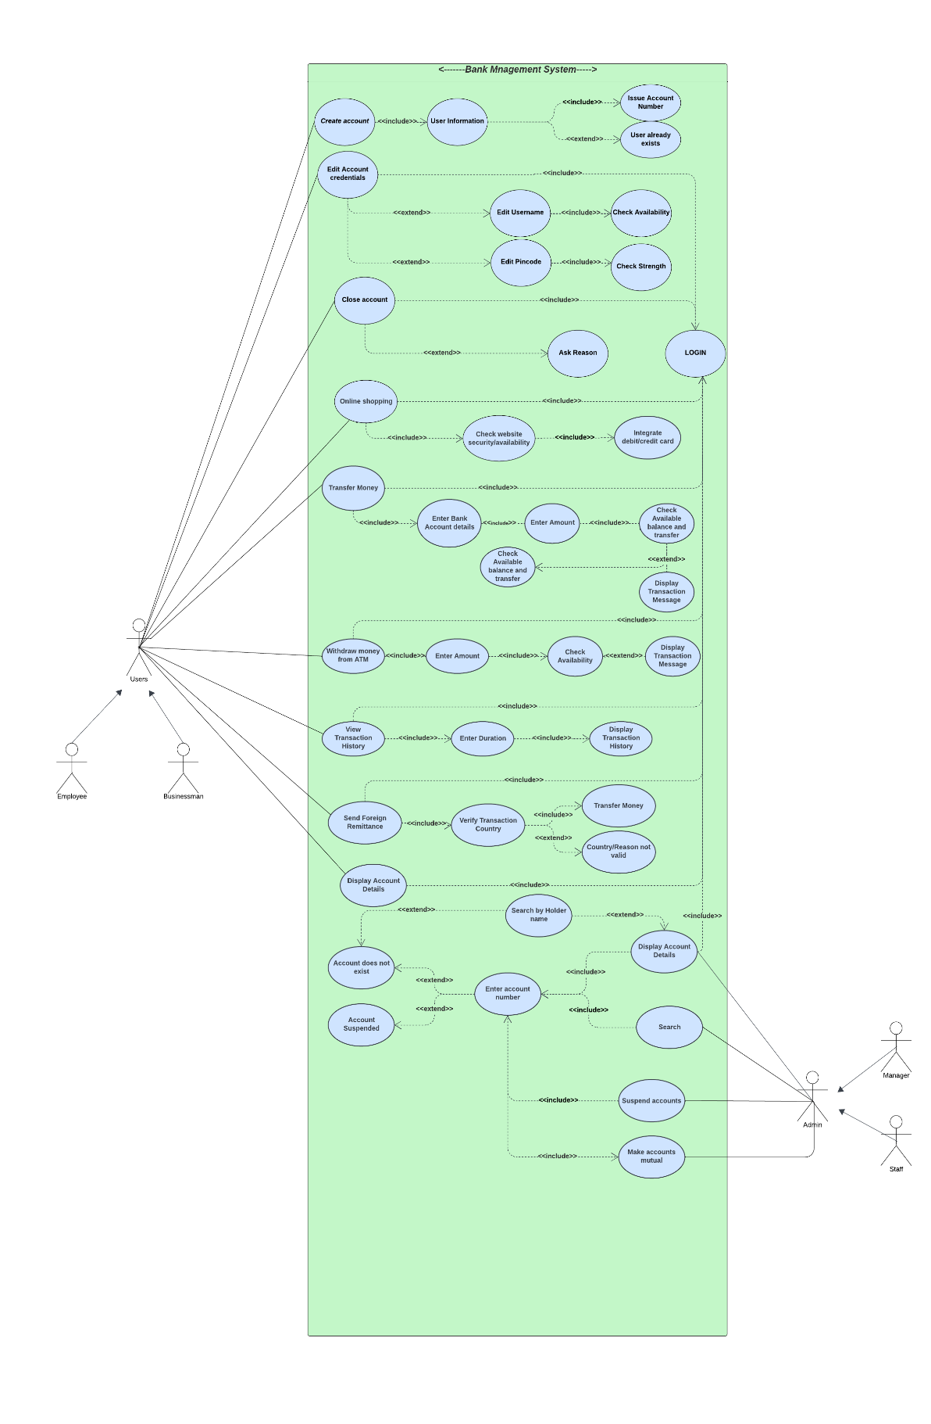

**Stakeholders**

The stakeholders of the project include:

* **Customers:** End-users who expect easy access to their accounts, secure transactions, and high-quality customer service.
* **Bank Employees**: Staff involved in day-to-day operations, including customer service representatives, tellers, loan officers, and managers.
* **Bank Management**: Senior executives and decision-makers who require detailed reports and data to run the bank efficiently.
* **IT/Development Team**: The technical team responsible for building, testing, and maintaining the system.
* By creating an efficient and secure bank management system, this project will deliver significant improvements in operational efficiency, customer satisfaction, and security for all stakeholders involved.

**GANTT CHART**

| **Task ID** | **Task Name** | **Duration** | **Start Date** | **End Date** | **Dependencies** |
| --- | --- | --- | --- | --- | --- |
| 1 | **Requirements Gathering** | 2 weeks | 2024-12-01 | 2024-12-14 | - |
| 2 | **System Design** | 3 weeks | 2024-12-15 | 2024-12-31 | Task 1 |
| 3 | **Database Design** | 2 weeks | 2024-12-15 | 2024-12-28 | Task 2 |
| 4 | **UI/UX Design** | 3 weeks | 2024-12-15 | 2025-01-04 | Task 2 |
| 5 | **Frontend Development** | 4 weeks | 2025-01-05 | 2025-02-01 | Task 4 |
| 6 | **Backend Development** | 5 weeks | 2025-01-05 | 2025-02-08 | Task 3 |
| 7 | **Integration and Testing** | 4 weeks | 2025-02-09 | 2025-03-08 | Task 5, 6 |
| 8 | **System Testing and Bug Fixing** | 2 weeks | 2025-03-09 | 2025-03-22 | Task 7 |
| 9 | **Deployment** | 1 week | 2025-03-23 | 2025-03-29 | Task 8 |
| 10 | **Post-Deployment Support** | Ongoing | 2025-03-30 | Ongoing | Task 9 |

**PROTOTYPES**

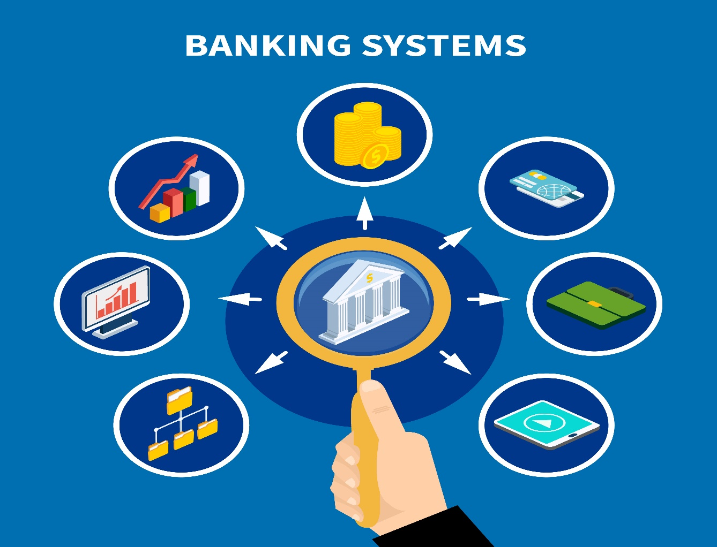

# **Activity Diagram of the System:**

# 

## **UML Diagram of the System:**

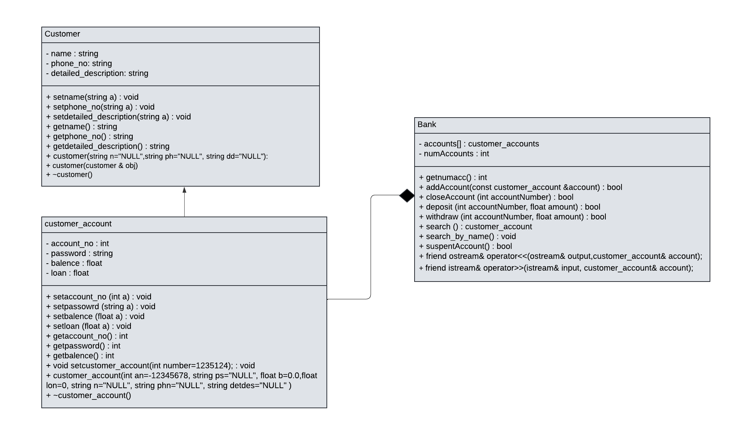

**ERD DIAGRAM**

+------------------+ +------------------+ +------------------+

| Customer | | Account | | Transaction |

+------------------+ +------------------+ +------------------+

| CustomerID (PK) | | AccountID (PK) | | TransactionID (PK) |

| Name | | AccountNumber | | TransactionDate |

| Address | | Balance | | Amount |

| Phone Number | | AccountType | | TransactionType |

| Email | | DateOpened | | FromAccountID (FK)|

| Date of Birth | | Status | | ToAccountID (FK) |

+------------------+ +------------------+ | Description |

| | +------------------+

| |

+------------------+ |

| Employee | |

+------------------+ |

| EmployeeID (PK) | |

| Name | |

| Position | |

| BranchID (FK) | |

| ContactInfo | |

+------------------+ |

| |

+------------------+ |

| Branch | |

+------------------+ |

| BranchID (PK) | |

| BranchName | |

| BranchLocation | |

| BranchManager (FK) | <-----+

+------------------+

**BFD DIAGRAM**

# **+----------------------------+ +---------------------+**

# **| Start (Login) | | Customer Login |**

# **+----------------------------+ +---------------------+**

# **| |**

# **V V**

# **+-------------------+ +---------------------+**

# **| Credentials Check| |Account Management |**

# **+-------------------+ +---------------------+**

# **| |**

# **+---------+----------+ +------------+-----------+**

# **| | | |**

# **V V V V**

# **[Login Failed] [Login Success] [View Balance] [Deposit Funds]**

# **| | | |**

# **+---Retry Login--------+ V V**

# **[Withdraw Funds] [Transfer Funds]**

# **| |**

# **V V**

# **[Transaction Processing] [Transaction Processing]**

# **| |**

# **V V**

# **[Deposit/Withdraw/Transfer]**

# **12. Graphic User Interface**

## **12.1 Splash Screen**

This screen will appear one the mobile application has started.

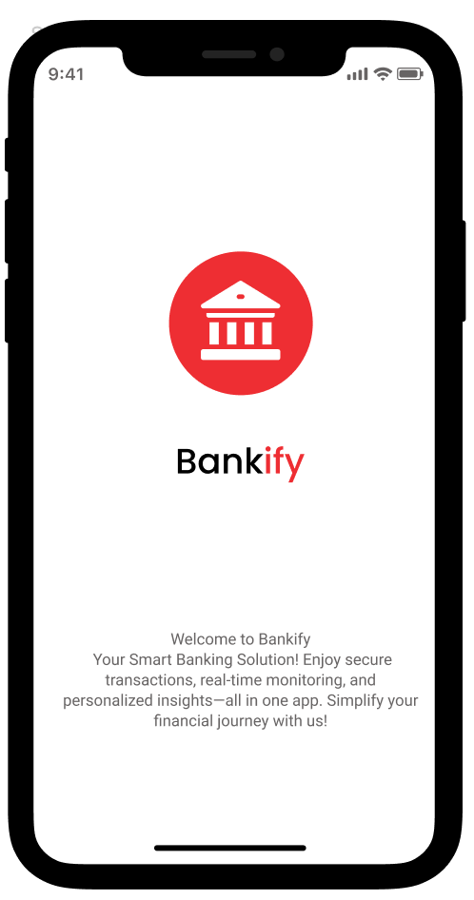

**12.1** Splash Screen for Bankify

## **12.2 Login Page**

Login page will appear after a delay of 800 microseconds from splash screen.

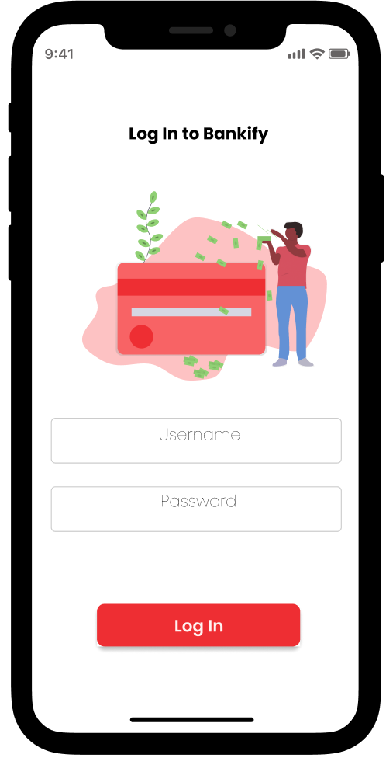

**12.2** Login page of Bankify

## **12.3 Home Screen**

Home screen will appear once user enters credentials and presses the login button.

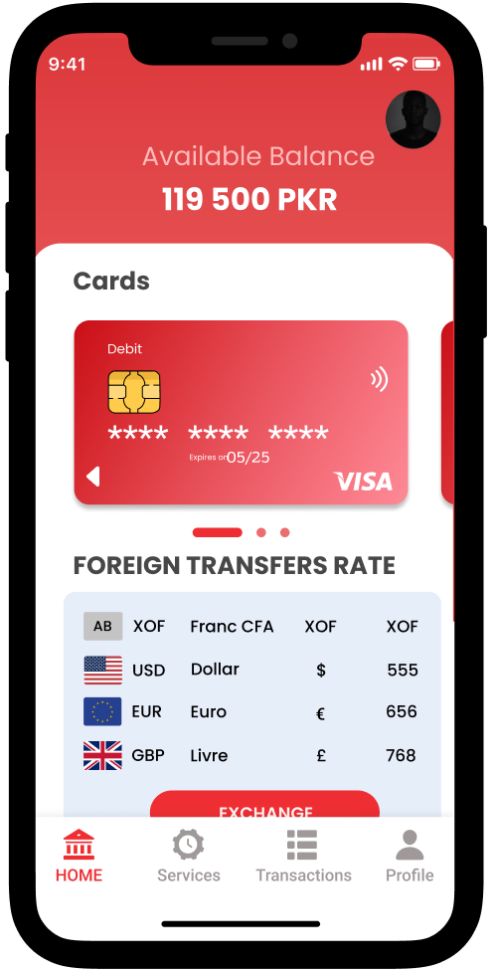

**12.3** Homepage of Bankify

## **12.4 Transaction Page**

Once user presses transaction page following transaction application page will show with the button to show full transaction history.

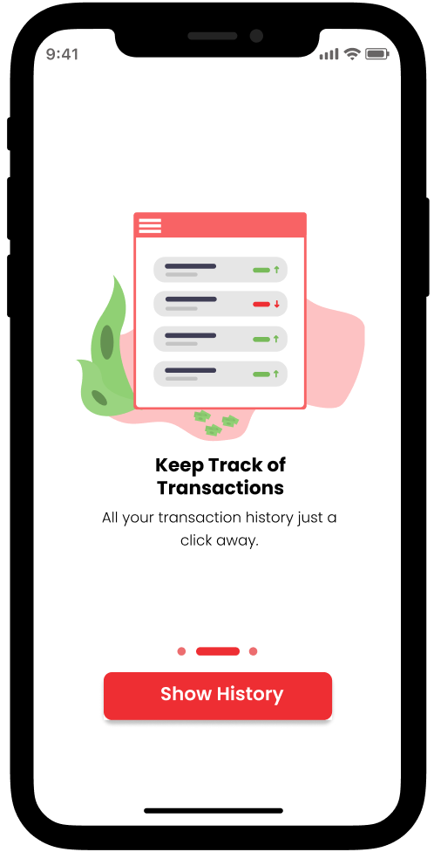

**12.4** Transaction page for Bankify

## **12.5 Transaction History Page**

When user presses “Show History” button following page of history of transactions will appear.

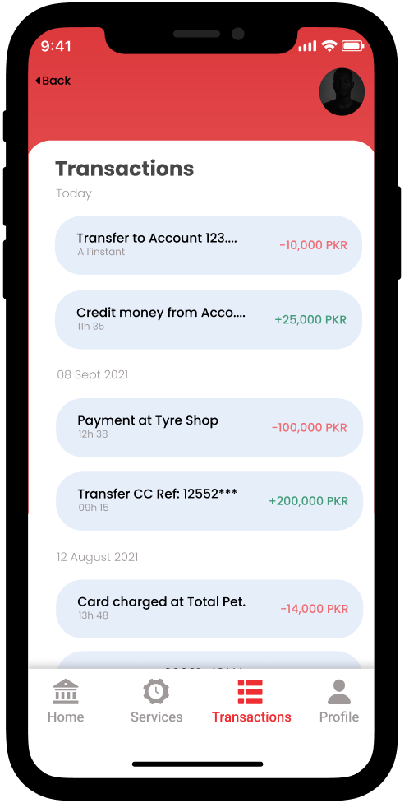

**12.5** Transactions History Page for Bankify

## **12.6 Profile Page**

When user clicks on profile button on navigation tab at the bottom following app will navigate to following profile page.

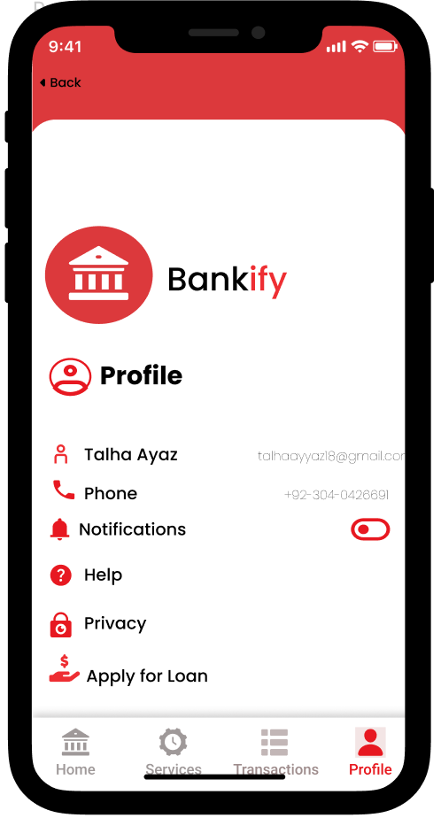

**12.6** Profile Page for Bankify

## **12.7 Services Page**

Our app offers services of paying utility bills, therefore once services button is pressed following page appears.

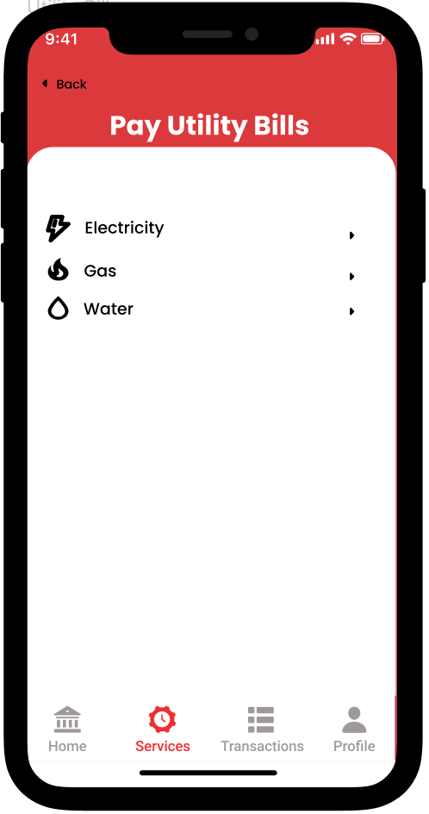

**12.7** Services Page of Bankify

## **12.8 Utility Bills Page**

After selecting the type of bill app will ask for consumer number for selected bill on the following page.

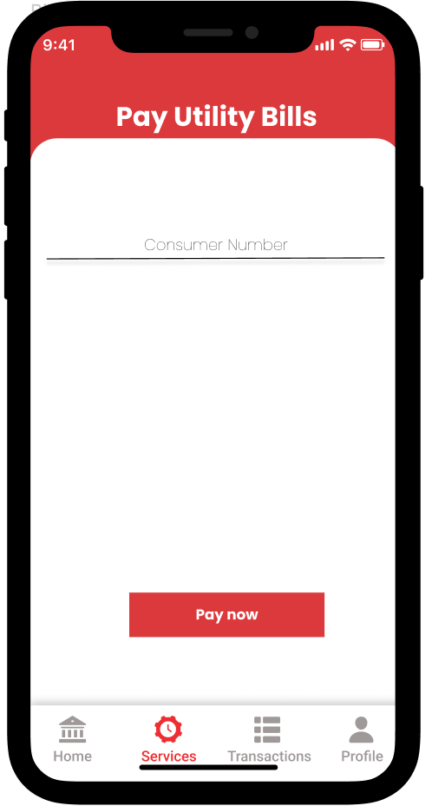

**12.8** Utility Bills Page for Bankify

## **12.9 Loan Page**

Our system offers loan as well. For that following page appears once user selects “Apply for Loan” option.

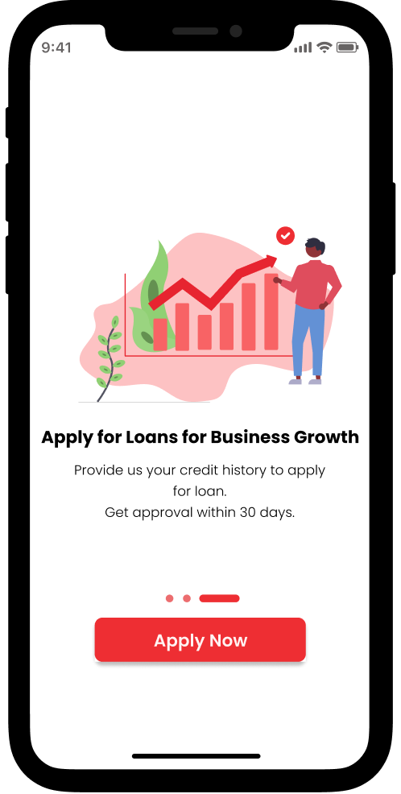

**12.9** Loan Page for Bankify

## **12.10 Card Application Page**

If a user wants to apply for Credit/Debit card he will click on “Cards” on homepage in order to be redirected to the following screen.

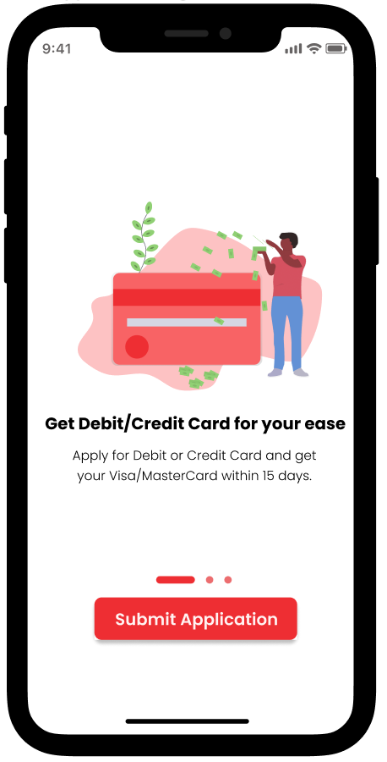

**12.10** Card Application Page for Bankify

## **12.11 Phone Verification Page**

When there’s a need to verify user’s phone number i.e., applying for loan or credit/debit card, in order to keep up with security concerns page below will appear.

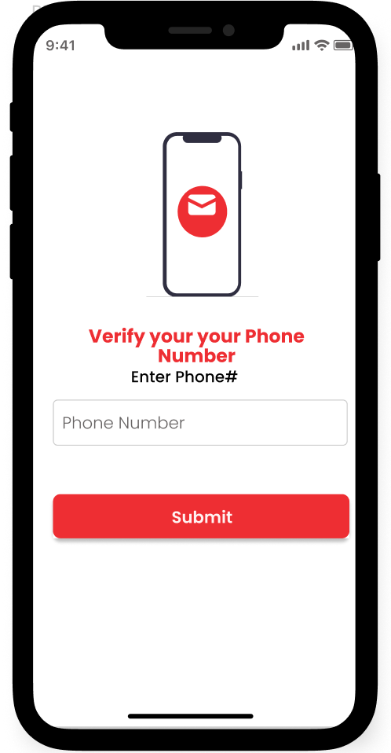

**12.11** Phone Number Verification for Bankify

## **12.12 OTP Verification Page**

After entering phone number user will be sent with one time password (OTP) that he will enter on the page below.

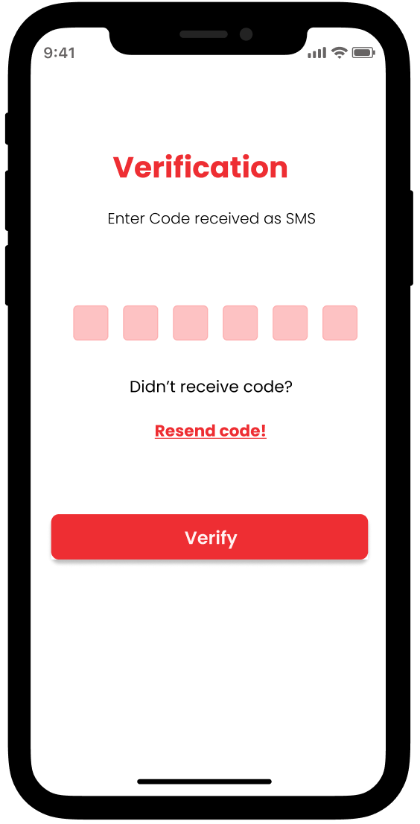

**12.12** OTP Verification Page for Bankify